Unit 2
Web Designing

1. What is HTML?
HTML is the standard markup language for creating Web pages.
- HTML stands for Hyper Text Markup Language
- HTML describes the structure of a Web page
- HTML consists of a series of elements

HTML Is Not Case Sensitive
- HTML elements tell the browser how to display the content
- HTML elements are represented by tags
- HTML tags label pieces of content such as "heading", "paragraph", "table", and so on
- Browsers do not display the HTML tags, but use them to render the content of the page

A Simple HTML Document

<!DOCTYPE html>
<html>
<head>
<title>Page Title</title>
</head>
<body>
<h1>My First Heading</h1>
<p>My first paragraph.</p>
</body>
</html>

Example Explained
- The <!DOCTYPE html> declaration defines this document to be HTML5
- The <html> element is the root element of an HTML page
- The <head> element contains meta information about the document
- The <title> element specifies a title for the document
- The <body> element contains the visible page content
- The <h1> element defines a large heading
- The <p> element defines a paragraph

Web Browsers
The purpose of a web browser (Chrome, Edge, Firefox, Safari) is to read HTML documents and display them.
The browser does not display the HTML tags, but uses them to determine how to display the document:
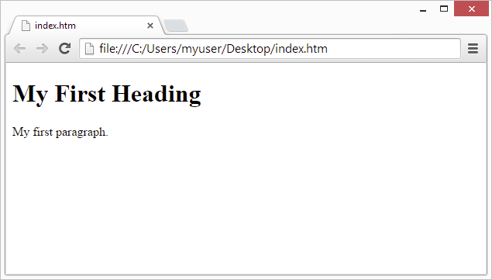

HTML Page Structure
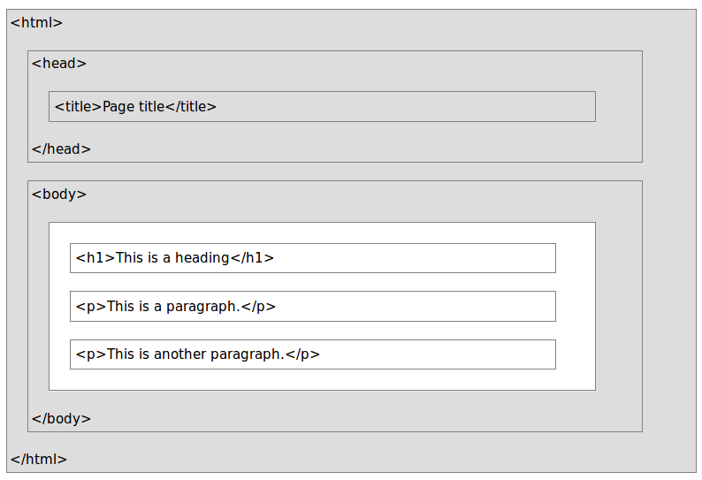
Below is a visualization of an HTML page structure:

HTML Versions
Since the early days of the web, there have been many versions of HTML:
Version | Year
HTML | 1991
HTML 2.0 | 1995
HTML 3.2 | 1997
HTML 4.01 | 1999
XHTML | 2000
HTML5 | 2014

2. Difference between container tag and empty tag

Empty Tag | Container Tag
While empty tag is tag without content or a closing tag | Container tag consists of opening tag+content+closing tag .
empty tags are used to insert something. Like if we want to insert an image or a line-break or a horizontal-line , we use <img />, <br />, <hr /> tags respectively. | Container tags are used to enclose texts, images etc. Like <body> , <div> etc are container tags as we put some content inside them.
Empty tags can be used inside the container tags. | Container tags can not be used inside the Empty tags.
Example:  - <hr>  - <br>  - <img> | Example:  - <p>...</p>  - <b>....</b>  - <i>....</i>

3. HTML Headings
Headings are defined with the <h1> to <h6> tags.
<h1> defines the most important heading. <h6> defines the least important heading.

Example
<html>
<body>

<h1>Heading 1</h1>
<h2>Heading 2</h2>
<h3>Heading 3</h3>
<h4>Heading 4</h4>
<h5>Heading 5</h5>
<h6>Heading 6</h6>
</body>
</html>
Output

Heading 1

Heading 2

Heading 3

Heading 4

Heading 5

Heading 6

4. HTML Horizontal Rules
The <hr> tag defines a thematic break in an HTML page, and is most often displayed as a horizontal rule.
The <hr> element is used to separate content (or define a change) in an HTML page:
Example
<html>
<body>
<h1>This is heading 1</h1>
<p>This is some text.</p>
<hr>
<h2>This is heading 2</h2>
<p>This is some other text.</p>
<hr>
<h2>This is heading 2</h2>
<p>This is some other text.</p>
</body>
</html>

Output

This is heading 1
This is some text.

This is heading 2
This is some other text.

This is heading 2
This is some other text.

5. HTML Paragraphs
The HTML <p> element defines a paragraph:

Example
<p>This is a paragraph.</p>
<p>This is another paragraph.</p>

Output
This is a paragraph.
This is a paragraph.

6. HTML Line Breaks
The HTML <br> element defines a line break.
Use <br> if you want a line break (a new line) without starting a new paragraph:

Example
<p>This is<br>a paragraph<br>with line breaks.</p>
Output
This is
a paragraph
with line breaks

7. The HTML <pre> Element
The HTML <pre> element defines preformatted text.
The text inside a <pre> element is displayed in a fixed-width font (usually Courier), and it preserves both spaces and line breaks:
<pre>
My Bonnie lies over the ocean.
My Bonnie lies over the sea.
My Bonnie lies over the ocean.
Oh, bring back my Bonnie to me.
</pre>

Output
The pre tag preserves both spaces and line breaks:
My Bonnie lies over the ocean.

My Bonnie lies over the sea.

My Bonnie lies over the ocean.

Oh, bring back my Bonnie to me.

8. HTML Formatting Elements
In the previous chapter, you learned about the HTML style attribute.
HTML also defines special elements for defining text with a special meaning.
HTML uses elements like <b> and <i> for formatting output, like bold or italic text.
Formatting elements were designed to display special types of text:
- <b> - Bold text
- <strong> - Important text
- <i> - Italic text
- <em> - Emphasized text
- <sub> - Subscript text
- <sup> - Superscript text
- <u>-Underline text

9. HTML <div> Tag

Example
A section in a document that will have a light blue background color:
<div >
<h3>This is a heading</h3>
<p>This is a paragraph.</p>
</div>

Definition and Usage
- The <div> tag defines a division or a section in an HTML document.
- The <div> element is often used as a container for other HTML elements to style them with CSS or to perform certain tasks with JavaScript.

Tips and Notes
Tip: The <div> element is very often used together with CSS, to layout a web page.
Note: By default, browsers always place a line break before and after the <div> element. However, this can be changed with CSS.

Attributes
Attribute | Value | Description
align | left  right  center  justify | Not supported in HTML5.  Specifies the alignment of the content inside a <div> element

10. HTML <span> Tag

Example
A <span> element used to color a part of a text:
<p>My mother has <span >blue</span> eyes.</p>

Definition and Usage
- The <span> tag is used to group inline-elements in a document.
- The <span> tag provides no visual change by itself.
- The <span> tag provides a way to add a hook to a part of a text or a part of a document.

11. HTML <a> Tag

Example
A link to W3Schools.com:
<a href="https://www.w3schools.com">Visit W3Schools.com!</a>

Definition and Usage
- The <a> tag defines a hyperlink, which is used to link from one page to another.
- The most important attribute of the <a> element is the href attribute, which indicates the link's destination.
By default, links will appear as follows in all browsers:
- An unvisited link is underlined and blue
- A visited link is underlined and purple
- An active link is underlined and red

Attributes

Attribute | Value | Description
href | URL | Specifies the URL of the page the link goes to
name | section_name | Not supported in HTML5. Use the global id attribute instead.  Specifies the name of an anchor
target | _blank  _parent  _self  _top  framename | Specifies where to open the linked document

12. HTML <table> Tag

Example
A simple HTML table, containing two columns and two rows:
<table>
<tr>
<th>Month</th>
<th>Savings</th>
</tr>
<tr>
<td>January</td>
<td>$100</td>
</tr>
</table>

Definition and Usage
- The <table> tag defines an HTML table.
- An HTML table consists of the <table> element and one or more <tr>, <th>, and <td> elements.
- The <tr> element defines a table row, the <th> element defines a table header, and the <td> element defines a table cell.
- A more complex HTML table may also include <caption>, <col>, <colgroup>, <thead>, <tfoot>, and <tbody> elements.

Attributes
Attribute | Value | Description
align | left  center  right | Not supported in HTML5.  Specifies the alignment of a table according to surrounding text
bgcolor | rgb(x,x,x)  #xxxxxx  colorname | Not supported in HTML5.  Specifies the background color for a table
border | 1  0 | Not supported in HTML5.  Specifies whether or not the table is being used for layout purposes
cellpadding | pixels | Not supported in HTML5.  Specifies the space between the cell wall and the cell content
cellspacing | pixels | Not supported in HTML5.  Specifies the space between cells
width | pixels  % | Not supported in HTML5.  Specifies the width of a table

13. HTML <tbody> Tag

Example
An HTML table with a <thead>, <tbody>, and a <tfoot> element:
<table>
<thead>
<tr>
<th>Month</th>
<th>Savings</th>
</tr>
</thead>
<tbody>
<tr>
<td>January</td>
<td>$100</td>
</tr>
<tr>
<td>February</td>
<td>$80</td>
</tr>
</tbody>
<tfoot>
<tr>
<td>Sum</td>
<td>$180</td>
</tr>
</tfoot>
</table>

Definition and Usage
- The <tbody> tag is used to group the body content in an HTML table.
- The <tbody> element is used in conjunction with the <thead> and <tfoot> elements to specify each part of a table (body, header, footer).
- Browsers can use these elements to enable scrolling of the table body independently of the header and footer. Also, when printing a large table that spans multiple pages, these elements can enable the table header and footer to be printed at the top and bottom of each page.
- The <tbody> tag must be used in the following context: As a child of a <table> element, after any <caption>, <colgroup>, and <thead> elements.

14. HTML <caption> Tag

Example
A table with a caption:
<table>
<caption>Monthly savings</caption>
<tr>
<th>Month</th>
<th>Savings</th>
</tr>
<tr>
<td>January</td>
<td>$100</td>
</tr>
</table>

Definition and Usage
- The <caption> tag defines a table caption.
- The <caption> tag must be inserted immediately after the <table> tag.

15. HTML <img> Tag

Example
How to insert an image:
<img src="smiley.gif" alt="Smiley face" height="42" width="42">

Definition and Usage
The <img> tag defines an image in an HTML page.
The <img> tag has two required attributes: src and alt.
Note: Images are not technically inserted into an HTML page, images are linked to HTML pages. The <img> tag creates a holding space for the referenced image.
Tip: To link an image to another document, simply nest the <img> tag inside <a> tags.

Attributes
Attribute | Value | Description
align | top  bottom  middle  left  right | Not supported in HTML5.  Specifies the alignment of an image according to surrounding elements
alt | text | Specifies an alternate text for an image
border | pixels | Not supported in HTML5.  Specifies the width of the border around an image
height | pixels | Specifies the height of an image
src | URL | Specifies the URL of an image
width | pixels | Specifies the width of an image

16. Ways to Define Color

Name
The color name depicts the specific name for the HTML color tag. As you know, CSS supports 140 color names, and you can use any of them for your elements.
<font color=”red”>Hello</font>

RGB value
The RGB value defines HTML color tag's content color by mixing red, green and blue values. For example, rgb(0, 0, 0) is used to define black RGB value:
RGB(0,0,0)
The first number describes the red color input, the second - the green color input, and the third one - the blue color input. The value of each color can vary from 0 to 255. See the examples below:
Example

<h2 style="color: rgb(252, 156, 249);">
I am using RGB codes to assign a color to this text
</h2>

HEX value
HEX color value works pretty similarly to RGB but looks different. For example, #ff0000 is used to define red HEX value:
#ff0000
When you define HEX, the code contains both numbers from 0 to 9 and letters from A to F to define the intensity of the color. The first two symbols determine red intensity, the two in the middle - green intensity, and the last two - blue intensity:
Example

<font color=”#ff00ff”>Hello</font>

17. HTML <canvas> Tag

Example
Draw a red square, on the fly, and show it inside the <canvas> element:
<canvas id="myCanvas"></canvas>
<script>
var canvas = document.getElementById("myCanvas");
var ctx = canvas.getContext("2d");
ctx.fillStyle = "#FF0000";
ctx.fillRect(0, 0, 80, 80);
</script>

Definition and Usage
- The <canvas> tag is used to draw graphics, on the fly, via scripting (usually JavaScript).
- The <canvas> tag is only a container for graphics, you must use a script to actually draw the graphics.
- The getContext() method returns an object that provides methods and properties for drawing on the canvas.
- This reference will cover the properties and methods of the getContext("2d") object, which can be used to draw text, lines, boxes, circles, and more - on the canvas.

Attributes
Attribute | Value | Description
height | pixels | Specifies the height of the canvas
width | pixels | Specifies the width of the canvas

Colors, Styles, and Shadows
Property | Description
fillStyle | Sets or returns the color, gradient, or pattern used to fill the drawing
strokeStyle | Sets or returns the color, gradient, or pattern used for strokes
shadowColor | Sets or returns the color to use for shadows
shadowBlur | Sets or returns the blur level for shadows
shadowOffsetX | Sets or returns the horizontal distance of the shadow from the shape
shadowOffsetY | Sets or returns the vertical distance of the shadow from the shape
<html>
<body>
<canvas id="myCanvas" width="300" height="150" style="border:1px solid #d3d3d3;">
Your browser does not support the HTML5 canvas tag.</canvas>

<script>
var c = document.getElementById("myCanvas");
var ctx = c.getContext("2d");
ctx.fillStyle = "#FF0000";
ctx.fillRect(20, 20, 150, 100);
</script>
<p><strong>Note:</strong> The canvas tag is not supported in Internet
Explorer 8 and earlier versions.</p>

</body>

</html>
Output

<html>
<body>
<canvas id="myCanvas" width="300" height="150" style="border:1px solid #d3d3d3;">
Your browser does not support the HTML5 canvas tag.</canvas>
<script>
var c = document.getElementById("myCanvas");
var ctx = c.getContext("2d");
ctx.beginPath();
ctx.moveTo(0, 0);
ctx.lineTo(300, 150);
ctx.stroke();
</script>
<p><strong>Note:</strong> The canvas tag is not supported in Internet
Explorer 8 and earlier versions.</p>
</body>

</html>
Output

19. HTML <form> Tag

Definition and Usage
- The <form> tag is used to create an HTML form for user input.
- The <form> element can contain one or more of the following form elements:
  - <input>
  - <textarea>
  - <button>
  - <select>
  - <option>
  - <fieldset>
  - <label>
<html>
<body>
<form action="/action_page.php">
First name: <input type="text" name="FirstName" value="Mickey"><br>
Last name: <input type="text" name="LastName" value="Mouse"><br>
<input type="submit" value="Submit">
</form>
<p>Click the "Submit" button and the form-data will be sent to a page on the server called "/action_page.php".</p>
</body>
</html>
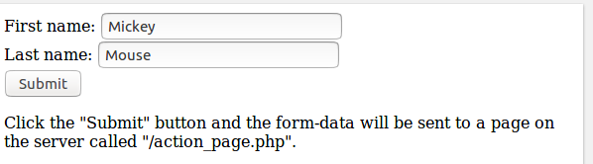
Output

Attributes

Attribute | Value | Description
action | URL | Specifies where to send the form-data when a form is submitted
method | get  post | Specifies the HTTP method to use when sending form-data
name | text | Specifies the name of a form
target | _blank  _self  _parent  _top | Specifies where to display the response that is received after submitting the form

20. HTML Form Elements

The <input> Element
The most important form element is the <input> element.
The <input> element can be displayed in several ways, depending on the type attribute.

Example
<input name="firstname" type="text">

The <select> Element
The <select> element defines a drop-down list:

Example
<select name="cars">
<option value="volvo">Volvo</option>
<option value="saab">Saab</option>
<option value="fiat">Fiat</option>
<option value="audi">Audi</option>
</select>
The <option> elements defines an option that can be selected.
By default, the first item in the drop-down list is selected.
To define a pre-selected option, add the selected attribute to the option:

Example
<option value="fiat" selected>Fiat</option>

Visible Values:
Use the size attribute to specify the number of visible values:

Example
<select name="cars" size="3">
<option value="volvo">Volvo</option>
<option value="saab">Saab</option>
<option value="fiat">Fiat</option>
<option value="audi">Audi</option>
</select>

Allow Multiple Selections:
Use the multiple attribute to allow the user to select more than one value:

Example
<select name="cars" size="4" multiple>
<option value="volvo">Volvo</option>
<option value="saab">Saab</option>
<option value="fiat">Fiat</option>
<option value="audi">Audi</option>
</select>

The <textarea> Element
The <textarea> element defines a multi-line input field (a text area):

Example
<textarea name="message" rows="10" cols="30">
The cat was playing in the garden.
</textarea>
The rows attribute specifies the visible number of lines in a text area.
The cols attribute specifies the visible width of a text area.
This is how the HTML code above will be displayed in a browser:
The cat was playing in the garden.

Example
<textarea name="message" style="width:200px; height:600px;">
The cat was playing in the garden.
</textarea>

The <button> Element
The <button> element defines a clickable button:

Example
<button type="button" onclick="alert('Hello World!')">Click Me!</button>

21. HTML Multimedia
Multimedia on the web is sound, music, videos, movies, and animations.

What is Multimedia?
Multimedia comes in many different formats. It can be almost anything you can hear or see.
Examples: Images, music, sound, videos, records, films, animations, and more.
Web pages often contain multimedia elements of different types and formats.
In this chapter you will learn about the different multimedia formats.

Multimedia Formats
Multimedia elements (like audio or video) are stored in media files.
The most common way to discover the type of a file, is to look at the file extension.
Multimedia files have formats and different extensions like: .swf, .wav, .mp3, .mp4, .mpg, .wmv, and .avi.

HTML5 Video
<html>
<body>
<video width="400" controls>
<source src="mov_bbb.mp4" type="video/mp4">
<source src="mov_bbb.ogg" type="video/ogg">
Your browser does not support HTML5 video.
</video>

<p>
Video courtesy of
<a href="https://www.bigbuckbunny.org/" target="_blank">Big Buck Bunny</a>.
</p>
</body>
</html>

Playing Videos in HTML
Before HTML5, a video could only be played in a browser with a plug-in (like flash).
The HTML5 <video> element specifies a standard way to embed a video in a web page.

How it Works
The controls attribute adds video controls, like play, pause, and volume.
It is a good idea to always include width and height attributes. If height and width are not set, the page might flicker while the video loads.
The <source> element allows you to specify alternative video files which the browser may choose from. The browser will use the first recognized format.
The text between the <video> and </video> tags will only be displayed in browsers that do not support the <video> element.

HTML <video> Autoplay
To start a video automatically use the autoplay attribute:

Example
<video width="320" height="240" autoplay>
<source src="movie.mp4" type="video/mp4">
<source src="movie.ogg" type="video/ogg">
Your browser does not support the video tag.
</video>

HTML Video - Media Types

File Format | Media Type
MP4 | video/mp4
WebM | video/webm
Ogg | video/ogg

HTML5 Video Tags
Tag | Description
<video> | Defines a video or movie
<source> | Defines multiple media resources for media elements, such as <video> and <audio>
<track> | Defines text tracks in media players

HTML5 Audio

Audio on the Web
Before HTML5, audio files could only be played in a browser with a plug-in (like flash).
The HTML5 <audio> element specifies a standard way to embed audio in a web page.

<html>
<body>
<audio controls>
<source src="horse.ogg" type="audio/ogg">
<source src="horse.mp3" type="audio/mpeg">
Your browser does not support the audio element.
</audio>
</body>
</html>

HTML Audio - How It Works
The controls attribute adds audio controls, like play, pause, and volume.
The <source> element allows you to specify alternative audio files which the browser may choose from. The browser will use the first recognized format.
The text between the <audio> and </audio> tags will only be displayed in browsers that do not support the <audio> element.

HTML Audio - Media Types
File Format | Media Type
MP3 | audio/mpeg
OGG | audio/ogg
WAV | audio/wav

HTML5 Audio Tags
Tag | Description
<audio> | Defines sound content
<source> | Defines multiple media resources for media elements, such as <video> and <audio>

HTML YouTube Videos
<html>
<body>
<iframe width="420" height="345" src="https://www.youtube.com/embed/tgbNymZ7vqY">
</iframe>
</body>
</html>

YouTube Autoplay
<html>
<body>
<iframe width="420" height="345" src="https://www.youtube.com/embed/tgbNymZ7vqY?autoplay=1">
</iframe>
</body>
</html>

22. Adobe Dreamweaver

Adobe Dreamweaver is a proprietary web development tool from Adobe Inc.. It was created by Macromedia in 1997[1] and developed by them until Macromedia was acquired by Adobe Systems in 2005.[2]
Adobe Dreamweaver is available for the macOS and Windows operating systems.
Following Adobe's acquisition of the Macromedia product suite, releases of Dreamweaver subsequent to version 8.0 have been more compliant with W3C standards. Recent versions have improved support for Web technologies such as CSS, JavaScript, and various server-side scripting languages and frameworks including ASP (ASP JavaScript, ASP VBScript, ASP.NET C#, ASP.NET VB), ColdFusion, Scriptlet, and PHP.

Features
- Adobe Dreamweaver is a web design and development application that uses both a visual design surface known as Live View and a code editor with standard features such as syntax highlighting, code completion, and code collapsing as well as more advanced features such as real-time syntax checking and code introspection for generating code hints to assist the user in writing code.
- Combined with an array of site management tools, Dreamweaver allows for its users to design, code and manage websites, as well as mobile content.
- Dreamweaver is an Integrated Development Environment (IDE) tool.
- You can live preview of changes for the frontend.
- Dreamweaver is positioned as a versatile web design and development tool that enables visualization of web content while coding.
- Dreamweaver, like other HTML editors, edits files locally then uploads them to the remote web server using FTP, SFTP, or WebDAV.
- Dreamweaver CS4 now supports the Subversion (SVN) version control system.
Since version 5, Dreamweaver supports syntax highlighting for the following languages out of the box:
- ActionScript
- Active Server Pages (ASP).
- C#
- Cascading Style Sheets (CSS)
- ColdFusion
- EDML
- Extensible HyperText Markup Language (XHTML)
- Extensible Markup Language (XML)
- Extensible Stylesheet Language Transformations (XSLT)
- HyperText Markup Language (HTML)
- Java
- JavaScript
- PHP
- Visual Basic (VB)
- Visual Basic Script Edition (VBScript)

